**LAPORAN TUGAS**

**MATA KULIAH ALGORITMA DAN STRUKTUR DATA**

Dosen Pengampu : Triana Fatmawati, S.T, M.T

**PERTEMUAN - 6 - Sorting**



**Nama : M. Zidna Billah Faza**

**NIM : 2341760030**

**Prodi : D-IV Sistem Informasi Bisnis**

**JURUSAN TEKNOLOGI INFORMASI**

**POLITEKNIK NEGERI MALANG**

**2024**

Latihan 1

1. Flowchart Visualisasi Bubble Sort

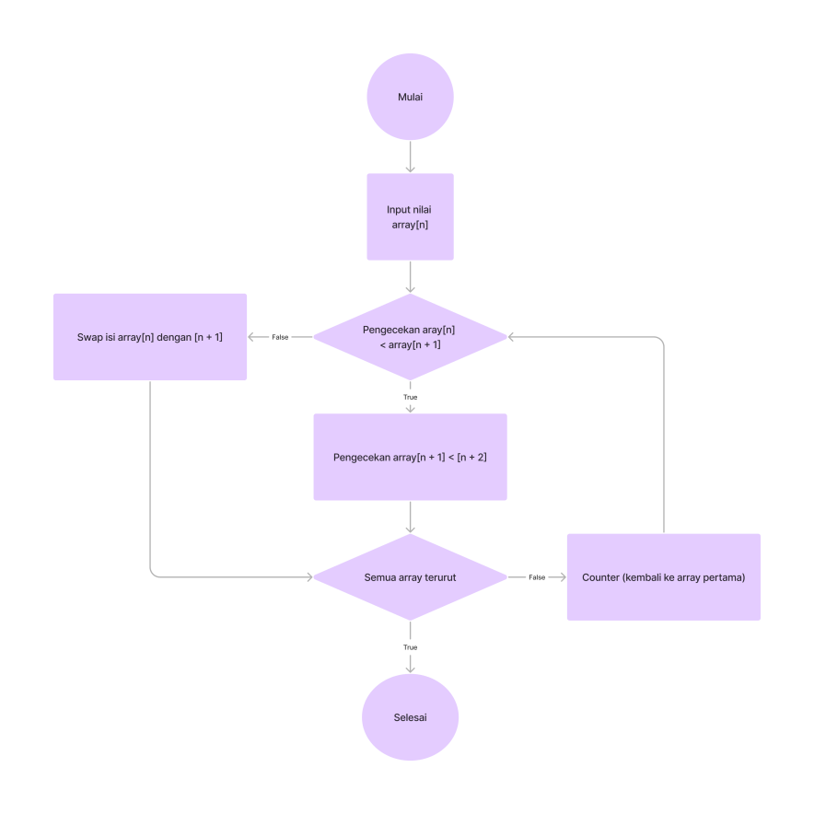

1. Flowchart Visualisasi Selection Sort

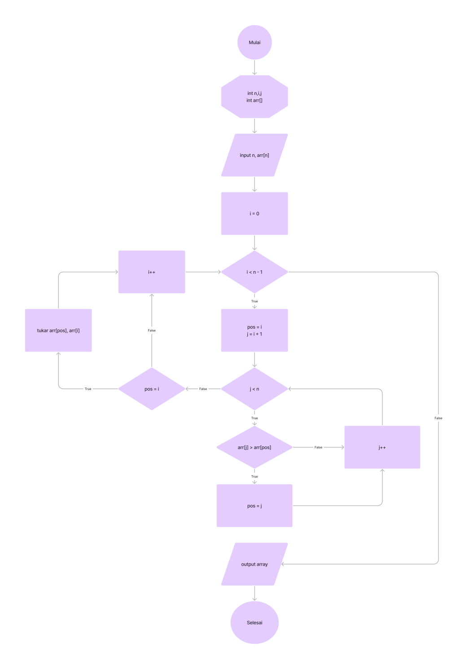

1. Flowchart Visualisasi Insertion Sort

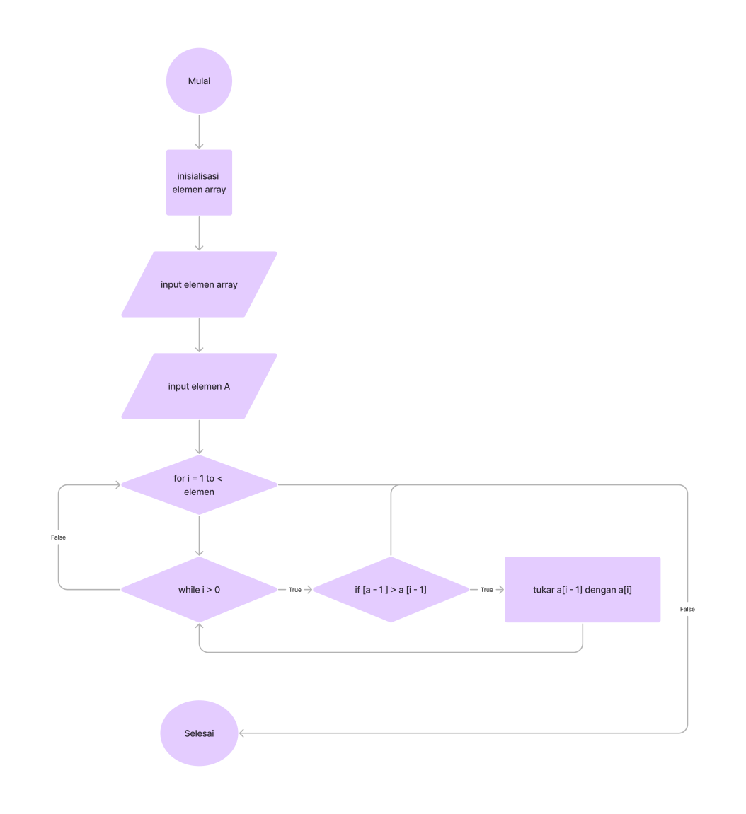

Latihan 2

1. Bubble Sort [23,35,7,14,67]

**Tahap 0** : 23 < 35 = swap [35,**23**,7,14,67]

: 23 < 7 = no swap [35,**23**,7,14,67]

: 7 < 14 = swap [35,23,14,**7**,67]

: 7 < 67 = swap [35,23,14,67,**7**]

**Tahap 1** : 35 < 23 = no swap [35,23,14,67,**7**]

: 23 < 14 = no swap [35,23,14,67,**7**]

: 14 < 67 = swap [35,23,67,**14**,7]

**Tahap 2** : 35 < 23 = no swap [35,23,67,14,7]

: 23 < 67 = swap [35,67,**23**,14,7]

**Tahap 3** : 35 < 67 = swap [67,**35**,23,14,7]

1. Selection Sort [23,35,7,14,67]

**Tahap 0** :

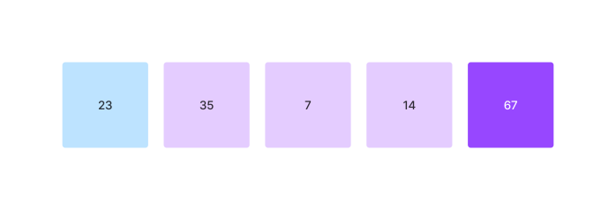

Index = 0; id = 0;

Max awal = 23

* 35 > 23 (Max = 35, id = 1)
* 7 > 35
* 14 > 35
* 67 > 35 (Max = 67, id = 4)

Swap index 0 dan id 4 [**67**,35,7,14,23]

**Tahap 1** :

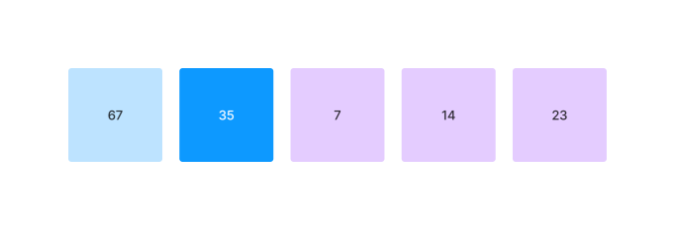

Index = 1; id = 1;

Max awal = 35

* 7 > 35
* 14 > 35
* 23 > 35

Swap index 1 dan id 1 [**67,35**,7,14,23]

**Tahap 2 :**

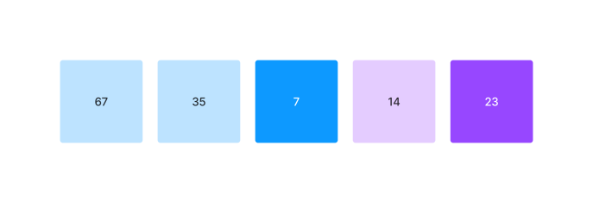

Index = 2; id = 2;

Max awal = 7;

* 14 > 7 (Max = 14, id = 3)
* 23 > 14 (Max = 23, id = 4)

Swap index 2 dan id 4 [**67,35,23,**14,7]

**Tahap 3 :**

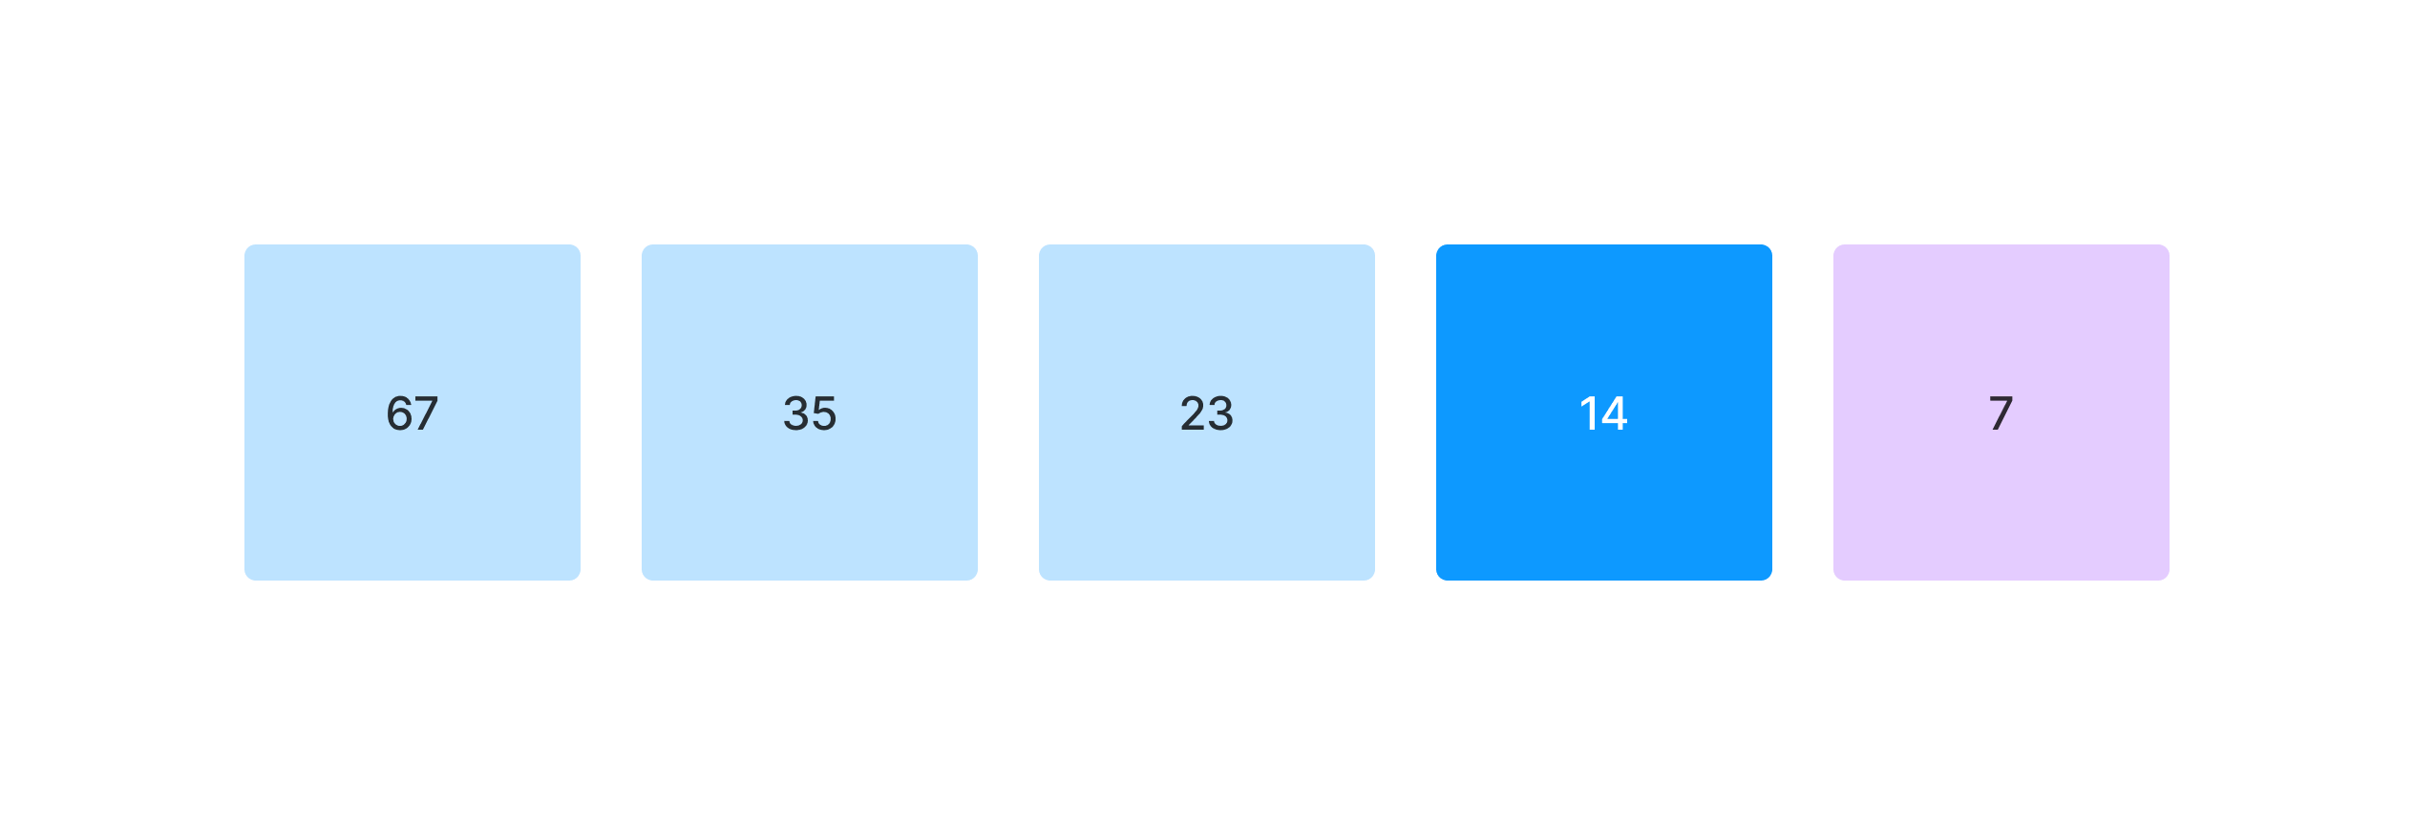

Index = 3; id = 3;

Max awal = 14

* 7 > 14 (Max = 14, id = 4)

Swap index 3 dan id 3 [**67,35,23,14**,7]

**Hasil Akhir :**

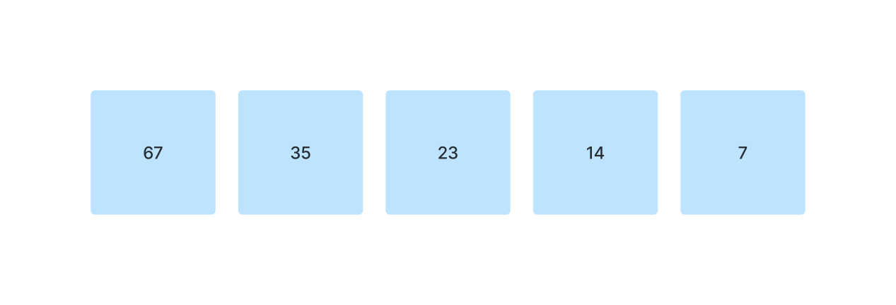

1. Insertion Sort

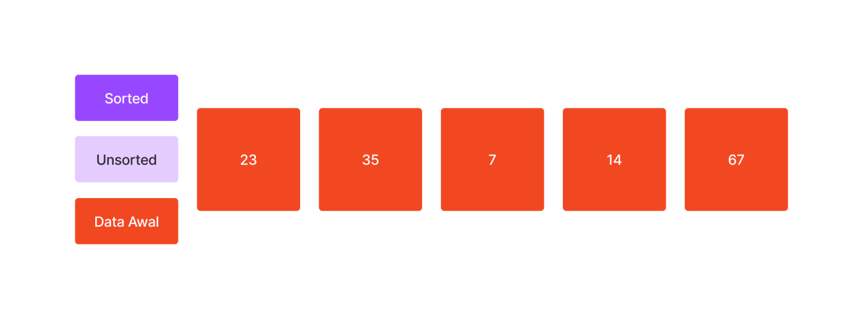

**Tahap 0 :**

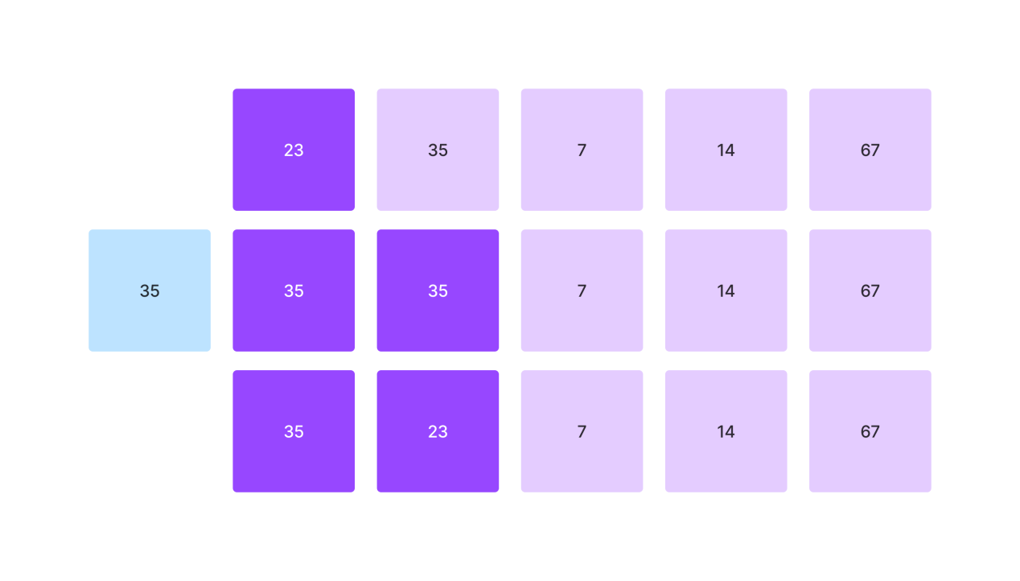

[23,35,7,14,67]

[35,35,7,14,67]

[**35,23,**7,14,67]

**Tahap 1 :**

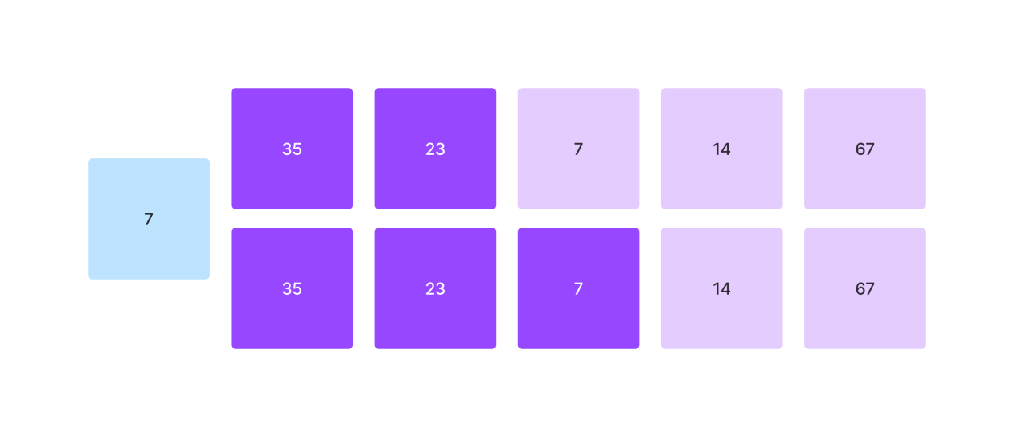

[35,23,7,14,67]

**[35,23,**7,14,67**]**

**Tahap 2 :**

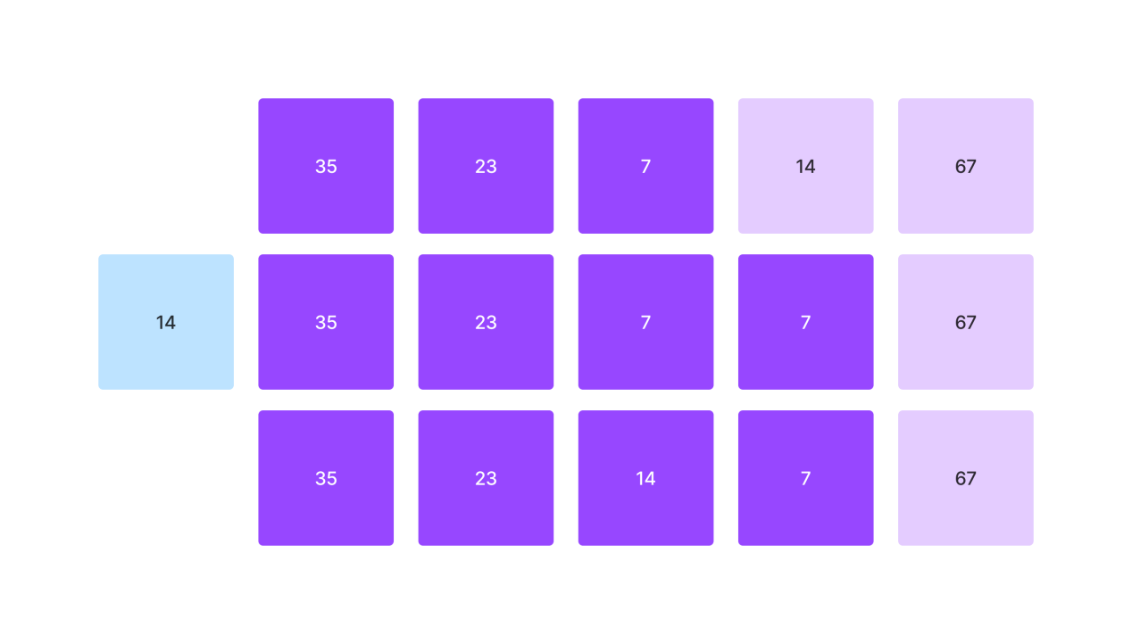

[35,23,7,14,67]

[35,23,7,7,67]

[**35,23,14**,7,67]

**Tahap 3 :**

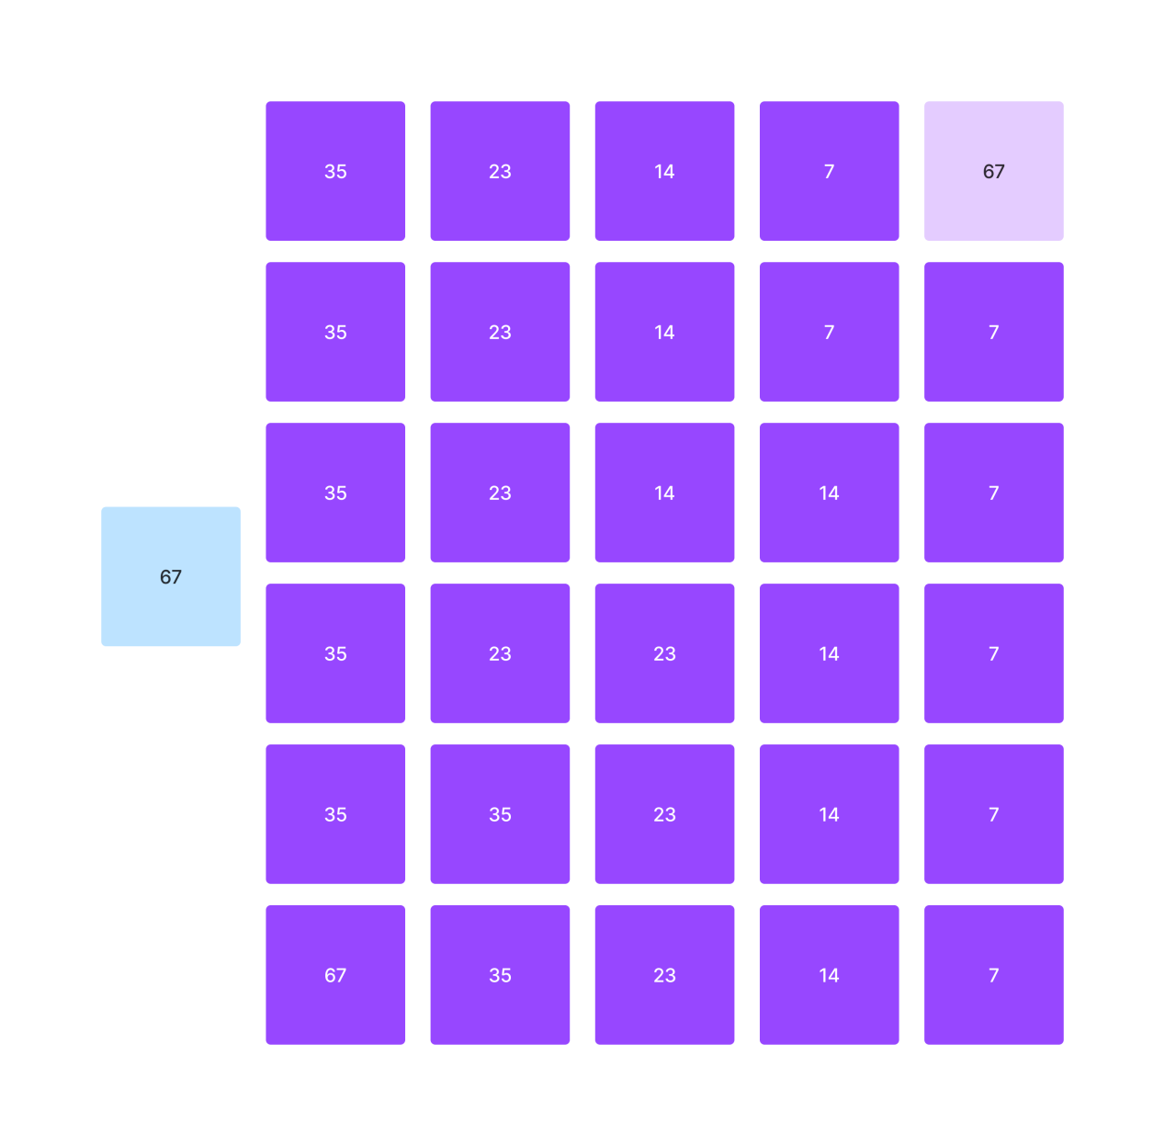

[35,23,14,7,67]

[35,23,14,7,7]

[35,23.14.14.7]

[35,23,23,14,7]

[35,35,23,14,7]

[**67,35,23,14**,7]

Repository GitHub : <https://github.com/zidnafaz/Algoritma-Struktur-Data>